

Oracle SQL Objects Extraction Smart Connector

Installation & Run Guide

Version 1.0

# 

Table of Contents

1. Introduction 3

1.1 Overview 3

1.2 Scope 3

1.3 Supported Operating Systems 3

2. Pre-requisites 3

2.1 Erwin DIS User Access 3

3. Installing the Connector 3

3.1 Steps to be performed on the server 3

3.2 Steps to be performed on Erwin DIS Application 6

4. Run Guide 7

4.1 Connector Options 7

4.2 Configuring the Connector 7

4.3 Running the Connector 8

1. Introduction
   1. Overview

This smart connector is used to extract the SQL objects from oracle and export to local drive.

This document aims to provide the steps to be followed to deploy the oracle stored procedure extraction smart connector to an existing DIS instance.

The operation consists of two parts

1. Placing the required supporting files in the required locations on the server where DIS is installed
2. Importing the connector into the Automation Framework module using the Import Connector functionality of DIS
   1. Scope

* Installation of required supporting files in the DIS Server.
* Importing the connector into Erwin DIS
  1. Supported Operating Systems
* Windows
* Linux

# 

1. Pre-requisites
   1. Erwin DIS User Access

* The user performing the import of the connector should have access to the Automation Framework Module in DIS

1. Installing the Connector
   1. Steps to be performed on the server

* Check if the user logged into the system has access to modify files in the tomcat installation path and has permissions to stop the Tomcat service
* Make sure the deployment package shared by Erwin contains a folder with the supporting jar files
* Stop the Tomcat service if it is already running, follow the steps below to stop tomcat based on the operating system
  + Windows System
    - Click on the start button at the bottom left corner of the screen
    - In the search bar, type in “Services” and locate the Services Application in the results

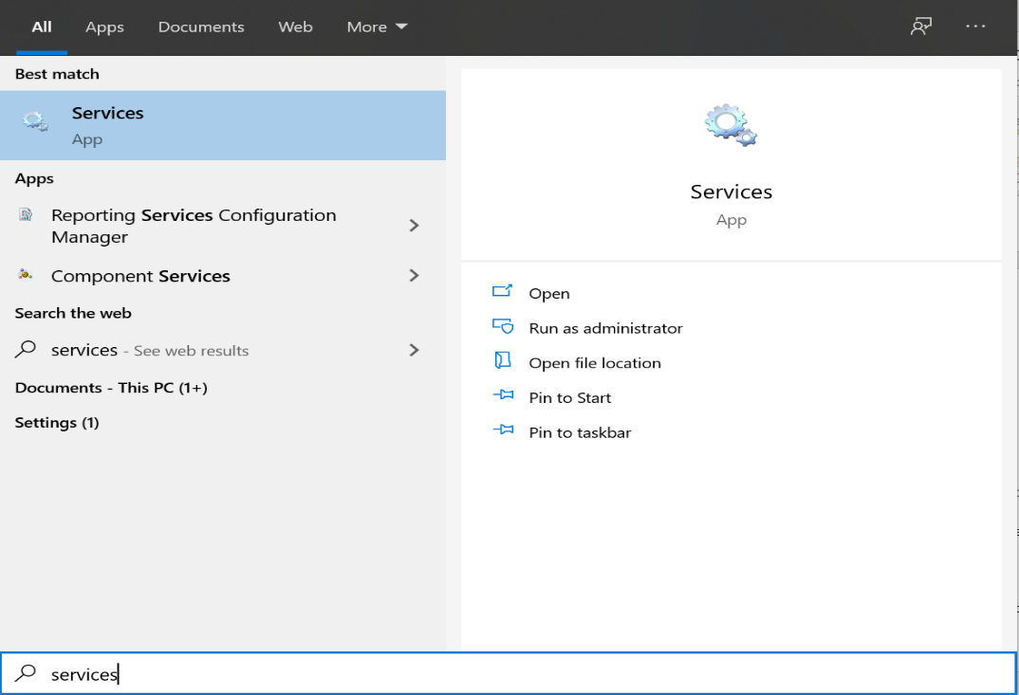

* + - Open the Services Application and find the “Apache Tomcat” service in the list of services

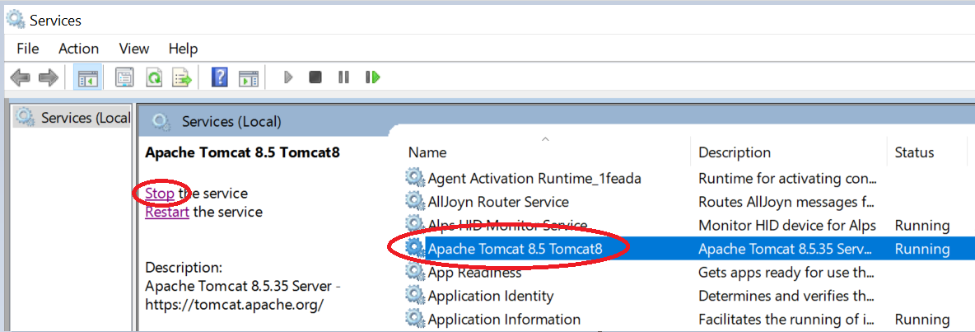

* + - Click on the service and then click on the Stop the service option to stop the Tomcat Service.
* Once the service is shutdown, open and clear the logs folder in the tomcat directory by deleting the log files
* Identify the application path for the DIS instance in tomcat, the application folder will be present in the webapps folder of tomcat.
* The generic path to the lib directory on the DIS instance is as follows:
  + *\*tomcat installation directory\**/webapps/*\*erwinDIS directory\**/WEB-INF/lib
* Copy all the supporting jar files from the deployment package shared by Erwin and place the files in the lib directory of the DIS instance

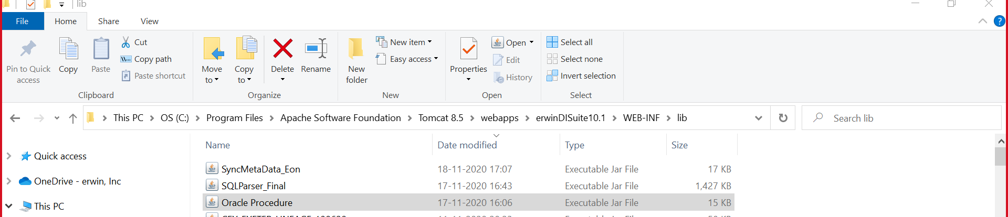

* After the files are copied into the lib directory, restart the Tomcat server.
  + Windows
    - On the services app, click on the Apache Tomcat service and click on the “Start the service” link

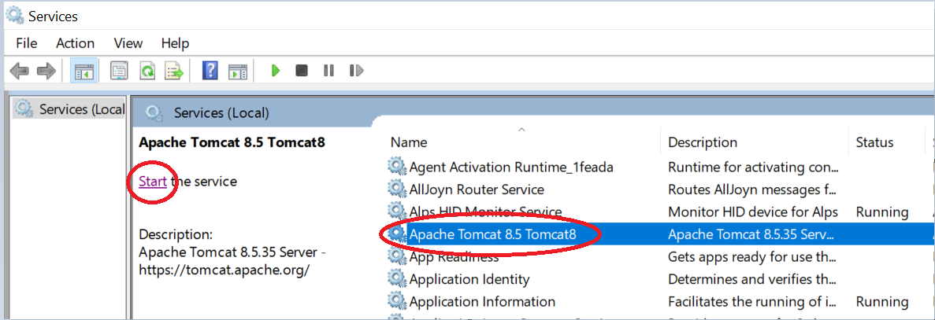

* 1. Steps to be performed on Erwin DIS Application
* Check if the Deployment package shared by Erwin has a folder containing .acp files. We will need those files to be imported into the DIS application to run the Informatica Connector
* Login to Erwin DIS application with a user who has access to the “Automation Framework” module.
* Click on the tile icon on the top left corner of the screen and navigate to the Automation Framework Module

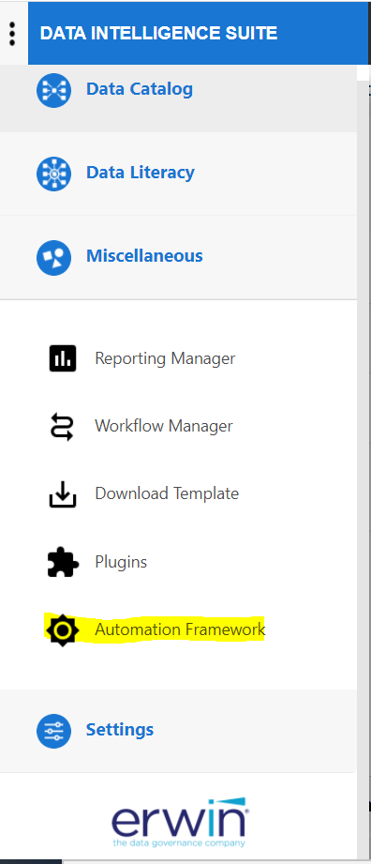

* Here under the CATs tab, we need to click on the Import Template option at the far right of the page and select the .acp file from the deployment package.

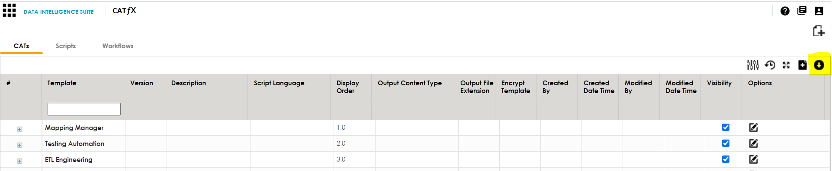

* In the pop-up window, click on the “Override with existing” option. This will replace any older version of the connector if already present on the DIS.

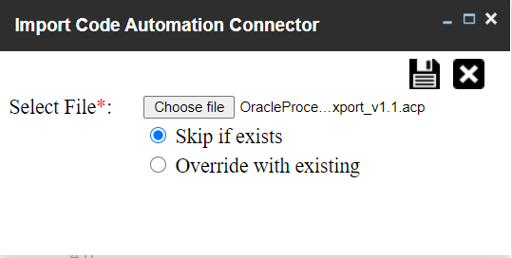

* Click on the “Save” icon on the top right of the pop-up window to finish the import process.
* Refresh the page and Check for the OracleProcedureExport_v1.1.acp connector template under SC Automation Support Group

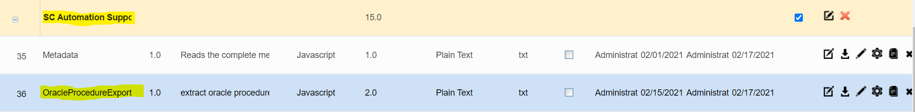

The connector has now been successfully installed onto the DIS instance, refer to the User Guide for the connector to understand the configuration options and steps to run the connector.

For any questions regarding the installation process please reach out to the Erwin team.

1. Run Guide
   1. Connector Options

The Oracle Export Reverse connector provides the following options:

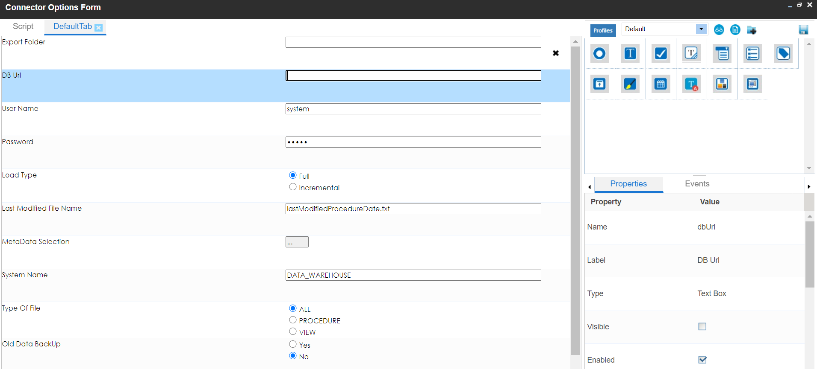

|  |  |
| --- | --- |
| ExportFolder | Provide the path where you need to export the stored procedures from oracle |
| DB url | Provide the oracle db connection details |

* 1. Configuring the Connector

The field details for the connector can be updated by right clicking on the connector and clicking on “Options”, or by clicking on the gear icon under the Options column alongside the connector name.

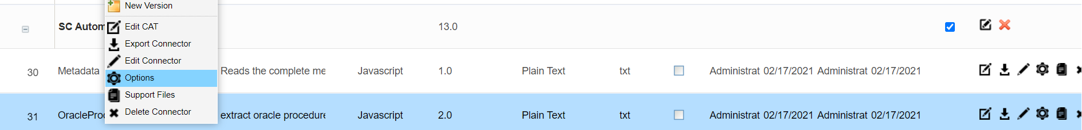

* The values specified in these fields determine the directory paths which the connector will use to pick the input files.
* All the above fields can also be edited at runtime.

Remember to click on the save button after making any updates to the Connector options

* 1. Running the Connector

The connector can be executed by following the steps below:

* Right click on the Project node in DIS Mapping Manager and click on “Run Template”.

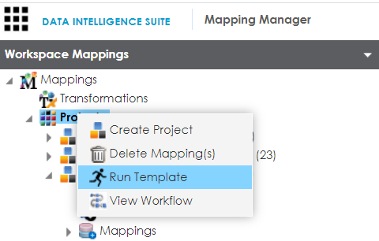

* On the next pop up window Navigate to the Tab “SC Automation Support” and locate the connector “OracleProcedureExport_v1.1” in the Connector List and click on “Export”.

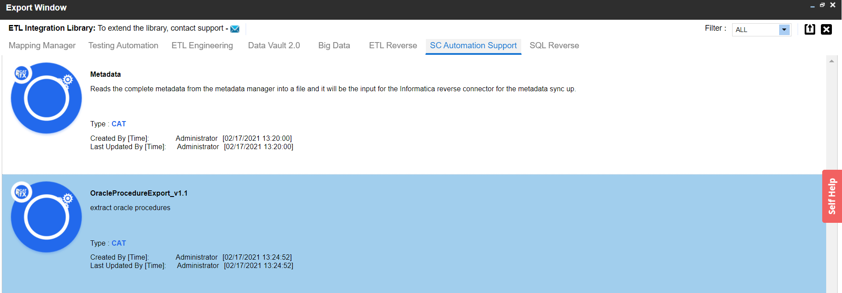

* Click on the green box in the top right corner to run the connector.

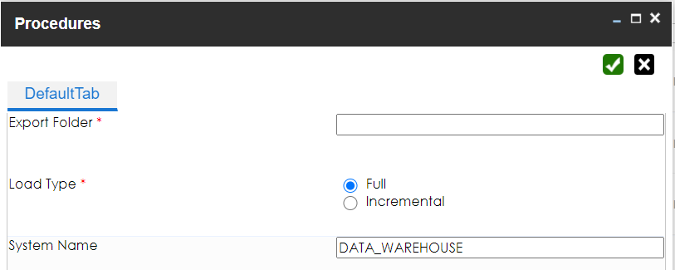

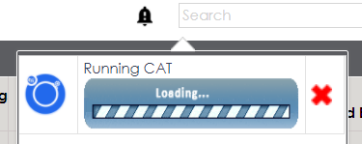

* Once the cat run is finished, navigate to the folder path which has been configured in cat options, where you can find the exported stored procedures from oracle

